Test Specifications

Cl659

Class: Registration

Method: test(String FirstName, String Surname, String Gender, Integer Age, String PhoneNumber, String DoctorChosen, String Details)

Test method( testRegDetailsCorrect())

Test case 1: Verify that the method returns true for correct details entered for method test.

Method: firstNameCheck(String firstName)

Test case 1: Verify that method firstNameCheck doesn’t accept empty string value. Returns false

Test case 2: Checks that firstName shouldn’t go over limit of character and returns false if so

Test case 3: Verify that firstNameCheck method shouldn’t accept any first names that include any numbers in, if so then it should return false.

Test case 4: Verify that null values shouldn’t be accepted within the method, if so, then Null Pointer Exception should return.

Method: surnameCheck(String surname)

Test method( surnameTest() )

Test case 1: Checks that surname shouldn’t be more than required characters, if so, then return false and display message to decrease characters

Test case 2: Verify that surname shouldn’t be less that required limit for surname, if it is then return false with message stating an increase in characters for surname.

Test case 3: Verify that surname cannot accept any numbers in surname, if so, return false and display message stating only letters

Test case 4: Checking for null values, if entered should throw Null Pointer Exception

Method: ageCheck(int age)

Test method( ageTest() )

Test case 1: This test checks for inputs less than 18 as new users registering that are under 18 need a guardian present. If input is less that 18 then it will display a message stating; you need to be 18 or over and return false.

Test case 2: Verify the age is not over limit, which is 130, if so, then display message “invalid age” and return false otherwise

Test case 3: Check for null values within age, if so, return null pointer exception.

Method phoneNumberCheck(String phoneNumber)

Test Method(phoneNumberTest())

Test case 1: if phone number is in wrong format, then display message stating invalid phone number format, then checks if it returns false if entered incorrectly.

Method checkDetails(String details)

Test method (detailsTest())

Test case 1: Check to see if details do not exceed limit if so, display message saying, “details too long” and return false.

Test case 2: Check for null values in details 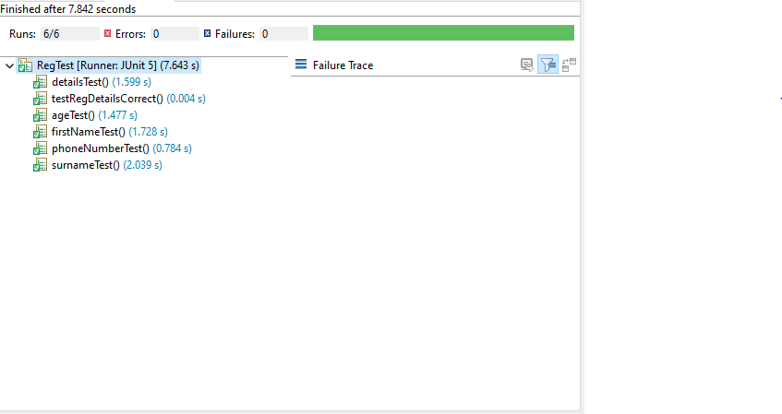, if entered throw return null pointer exception